Information regarding protected products offered for sale (or any other form of transfer)

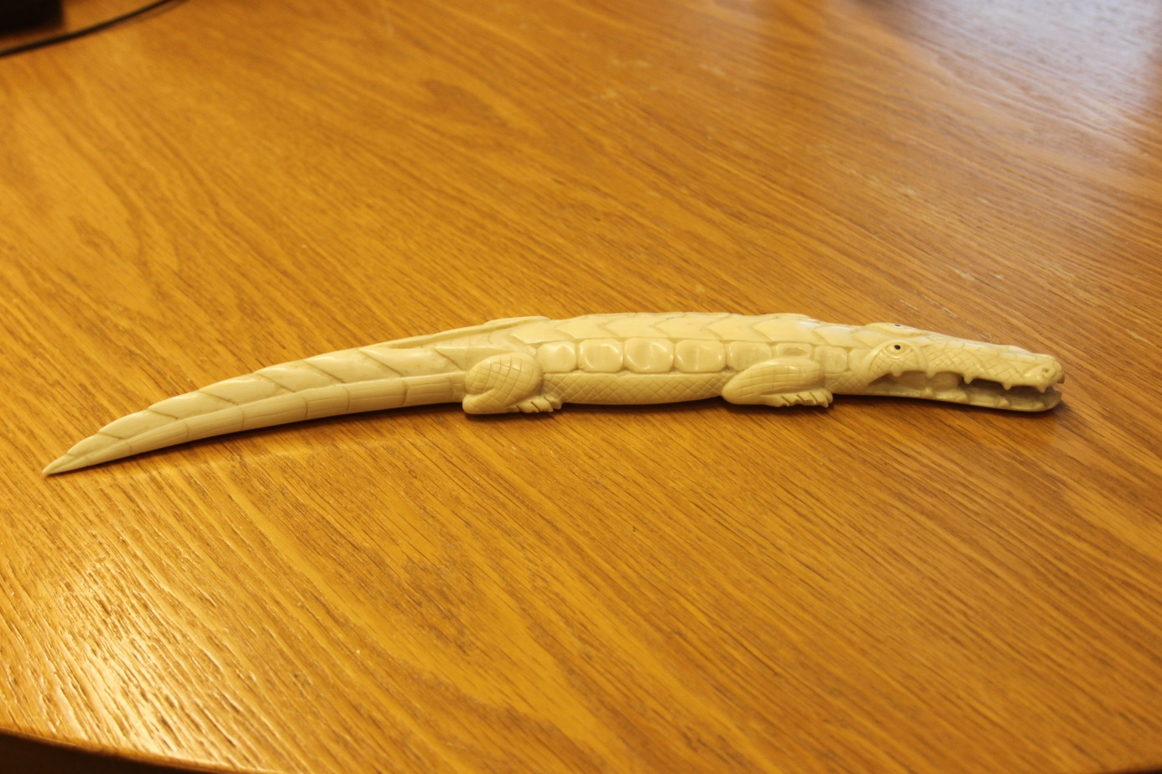

# Background

A considerable number of animal and plant species are protected under Dutch and/or European legislation. Additional conditions apply to the trade of these species to trace their legal origin. While ivory and rhinoceros horn are often the first things that come to mind, examples also include coral or taxidermied animals. In this document, we will highlight some of the regulations and products.

Inhoud

1. CITES 3

Ivory 4

Elephant ivory 4

How to recognize ivory? 4

Other ivory 6

2. Bird’s directive 8

1. Found dead 8

2. Bred bird 8

3. Game and damage-causing species 9

4. Habitat directive species 10

5. Bern and Bonn conventions 10

6. Other game- and damage causing species 11

7. Fur 12

Canadian lynx 12

Eurasian lynx 12

Ocelot 13

Wolf 13

Arctic fox 13

Zebra 14

Beer 14

Lion 14

8. Reptile leather 15

Reticulated python 15

Crocodile leather 15

Monitor lizards 16

9. Turtle and tortoise 16

Closing remarks 17

# CITES

CITES stands for 'Convention on International Trade in Endangered Species of Flora and Fauna.' This international agreement protects tens of thousands of animal and plant species that may be threatened by trade and other economic activities.

Beforehand, determine whether you have a CITES species (or a part thereof, such as ivory or coral). Because sometimes the species may not be easily recognizable or identifiable, you can find an overview of a small number of animals, plants, and examples of products covered by CITES legislation in Table 1. For all these products (including, for example, taxidermy animals), it is necessary to demonstrate their legal origin. You can use https://www.speciesplus.org to determine whether the animal or plant falls under CITES, using the scientific name.

Table 1: Examples of species covered by CITES regulations

|  |  |
| --- | --- |
| Animal/plant/product | Example |
| All birds of prey and owls | Taxidermied peregrine falcon |
| All stony corals | Piece of coral |
| Ivory from elephants, walruses, whales, or narwhals | Ivory figurines, cutlery, or jewelry (further explanation on how to recognize ivory will be provided later) |
| Alle large felines (subfamily Pantherinae) | Taxidermied tiger or lion pelt |

On the website of the Netherlands Enterprise Agency (RVO), more information can be found about CITES and its associated obligations. Scan the QR code next to this text to directly access the correct website. For any questions, feel free to contact RVO or NVWA. Also see:

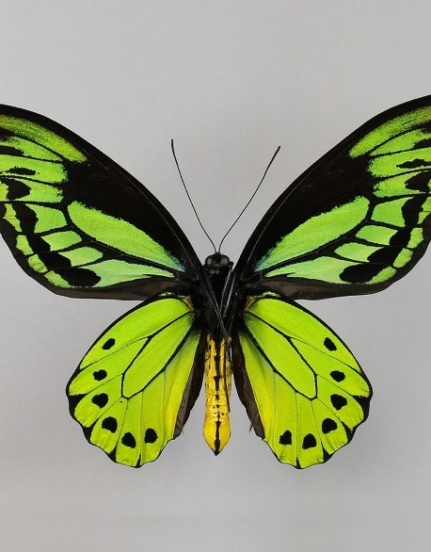<https://www.rvo.nl/onderwerpen/cites/dit-cites> [1]

A CITES-listed Ornithoptera-butterfly1

***Butterflies***

Often, butterflies are sold as taxidermy specimens. However, some butterfly species are also protected. The label often indicates the butterfly species. You can check whether the species is protected under CITES on the website [www.speciesplus.net](http://www.speciesplus.net) .

It's also possible that the butterfly is protected under the Habitats Directive. Refer to page 10 of this document for more information on this regulation.

## Ivory

Ivory is tooth material originating from land animals such as elephants, hippos, or mammoths, or sea creatures such as walruses or narwhals. Despite many people being aware that there are regulations associated with the trade of ivory items, recognizing it can still be a challenge at times.

### Elephant ivory

The first animal that comes to mind when discussing ivory is the elephant. There is also a lot of elephant ivory in circulation. There are two species of elephants: the African and the Asian elephant. The ivory from these species cannot be distinguished, so we generally refer to it as elephant ivory. Elephant ivory can only be traded if it is considered "antique" ivory and the appropriate paperwork is provided. For more information, please go to:

<https://www.rvo.nl/onderwerpen/cites/cites-soort/ivoor> (Dutch only)

### How to recognize ivory?

Unprocessed elephant ivory is easily recognized (see Figure 1). Vaak wordt het ivoor echter verwerkt tot andere voorwerpen (see for example figures 2 and 3).

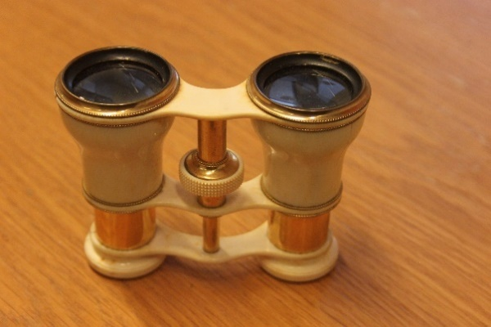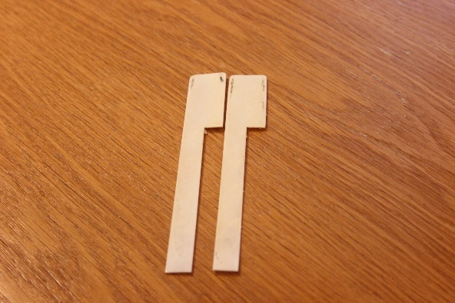Figuur 1: Tusk of an African elephant[2]

Figure 3: Pianokeys made from elephant ivory

Figuur 2: Binoculars made with elephant ivory

Identifying processed items as ivory can be somewhat more challenging. However, there are several indicators that can help distinguish it.

#### Temperature

Ivory is cooler to the touch than the ambient temperature. While this characteristic is present in multiple materials, it can serve as an indication that the material in question might be ivory.

#### Schreger lines

Perhaps the most definitive way to identify elephant ivory is by examining it from the cross-section, or the top view. Characteristic of elephant and mammoth ivory are the Schreger lines: these are V-shaped lines that repeat continuously across the entire surface. See figure 4 for an example. The lines are best observed with a magnifying glass, but this is not always necessary. Sometimes, the lines are concealed, making them (nearly) invisible.

The angle of the Schreger lines is important. Mammoth ivory also exists. Since mammoths have been extinct for some time, conservation measures are no longer necessary. Therefore, mammoth ivory is unprotected. The angle of the Schreger lines in mammoth ivory is almost always less than 90⁰ (Figure 4[3]), while in elephant ivory, the angle is generally greater than 115⁰ (Figure 5[4]). Mammoth ivory is also often slightly creamier or darker in color than elephant ivory.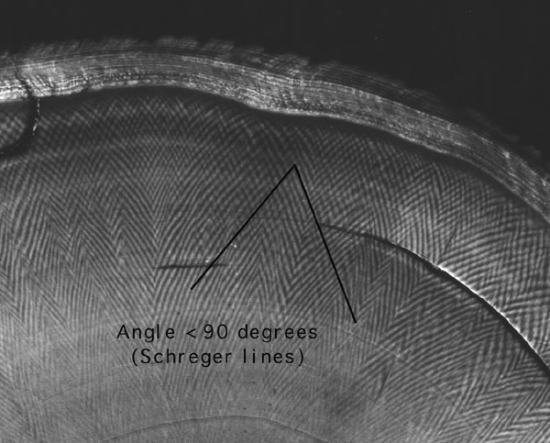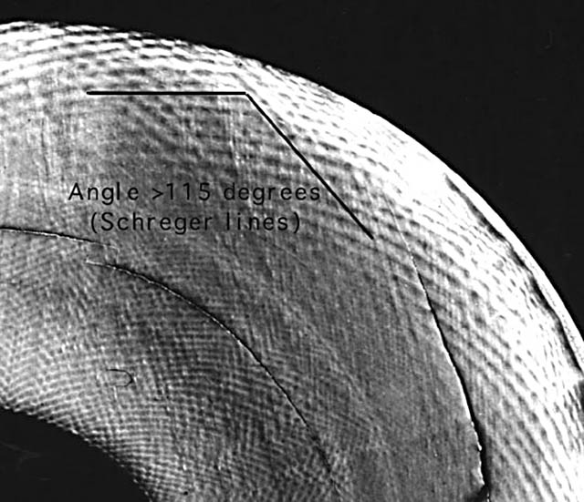

Figuur 5: Schreger lines in elephant ivory (protected). The angle of the V is greater than 115⁰

Figuur 4: Schreger lines in mammoth ivory (unprotected). The angle of the V is smaller than 90⁰

Identifying ivory can still be challenging at times. When in doubt, it's best to consult an expert.

### Other ivory

The most common ivory in circulation is elephant ivory. However, ivory can also originate from other animals. Below are some ivory items that may also be encountered..

#### Walrus

Walrus ivory is protected, and therefore its legal origin must be proven. This ivory is often found in dyed form. (figure 6) 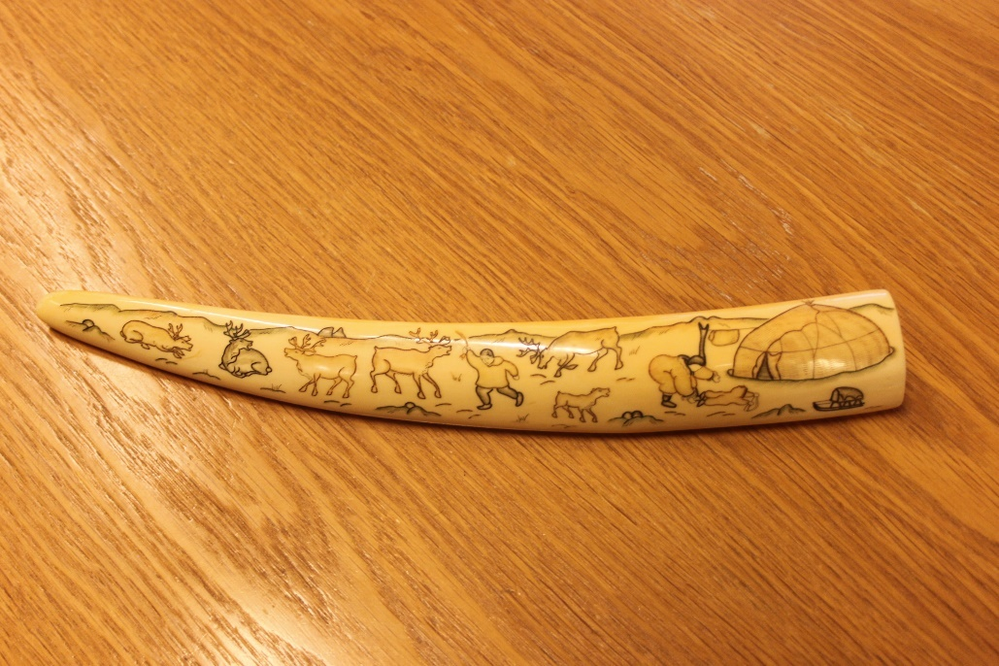

Figure 6: Walrus ivory

#### Hippopotamus

Ivory from the (pygmy) hippopotamus is protected, and thus the legal origin must be proven. The ivory from the canines typically has a rounded shape. (figure 7).

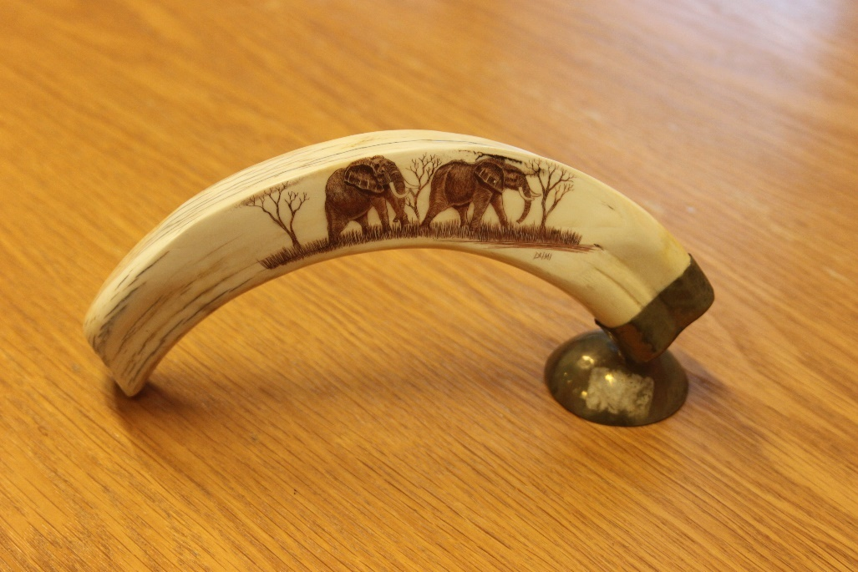

Figure 7: Hippopotamus ivory

#### Whales

Whale ivory is protected, so the legal origin must also be proven. Below is an example of ivory from the sperm whale. (figure 8).

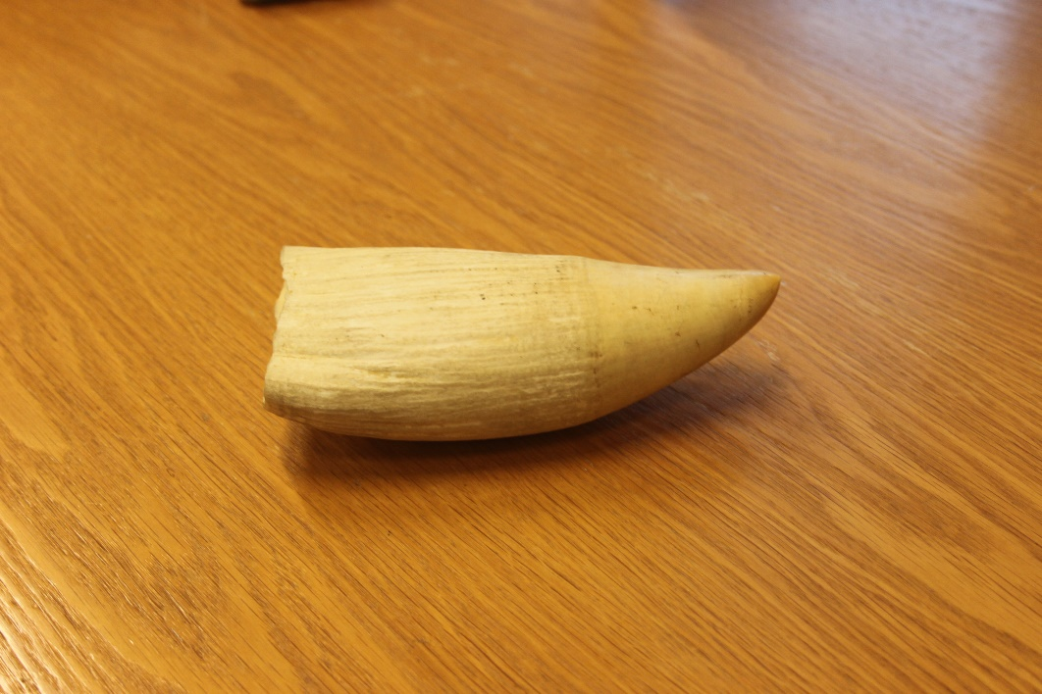

Figure 8: Sperm whale ivory

#### Warthog ivory

Finally, warthog ivory is also present in trade. Warthog is actually a collective term for several species of wild pigs. Ivory from all these warthogs is currently unprotected and can therefore be traded. The size is typically much smaller than the ivory previously mentioned. (figure 9).

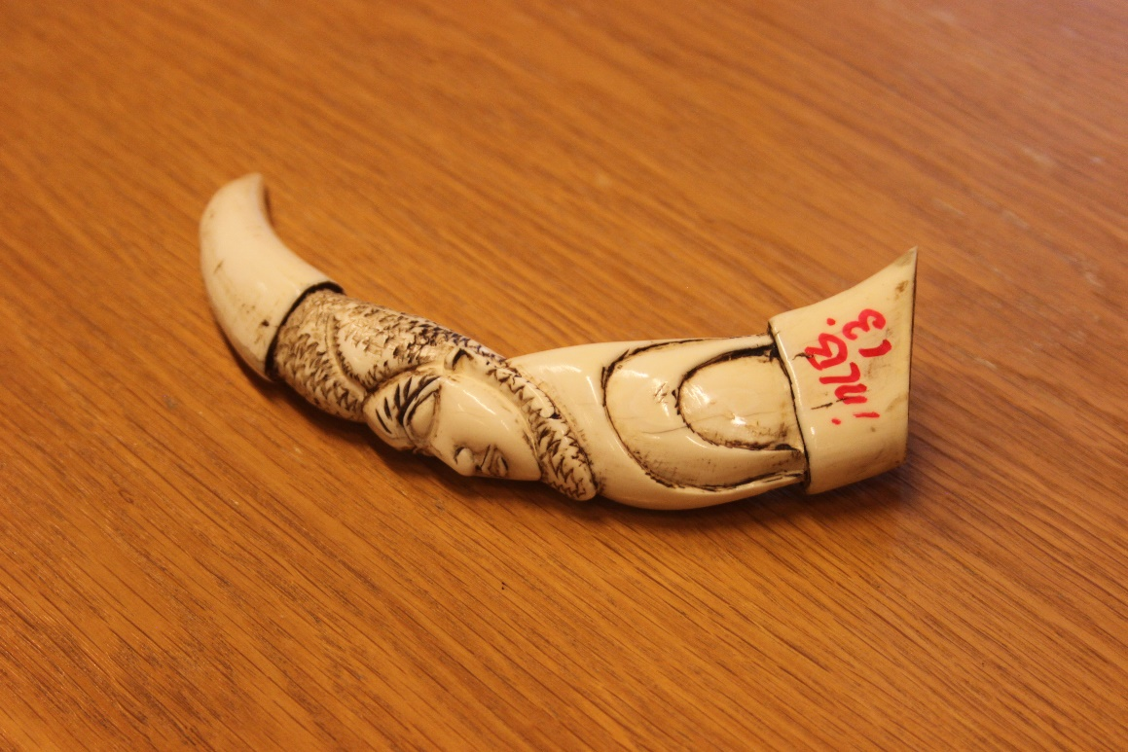

Figure 9: Warthog ivory

# Bird’s directive

Not only can species be protected under CITES, but there is also additional species protection legislation, such as the Birds Directive. This European legislation aims to protect native European bird populations.

If you're wondering which bird species fall under this directive, it's quite simple: all bird species occurring in Europe. From the house sparrow to the kingfisher, and from the blackbird to the peregrine falcon.

In the case that you possess (taxidermied) birds, there may be several regulations to consider.

## Found dead

If you find a dead bird protected under the Birds Directive, you are allowed to have it taxidermied. You must however report the bird to the RVO[5] (Netherlands Enterprise Agency) within three days. If you take the bird to a taxidermist, they will handle this for you. The taxidermist may taxidermy the bird for you, charging preparatory costs. However, the taxidermied bird may not be traded thereafter. **Selling a found taxidermied native bird is therefore prohibited.**

## Bred bird

In Europe, many native birds are also bred/cultivated. These birds are equipped with a seamless closed leg ring (Figure 10). This leg ring can only be fitted around the leg of very young birds. Therefore, this usually serves as sufficient evidence that the bird is bred.

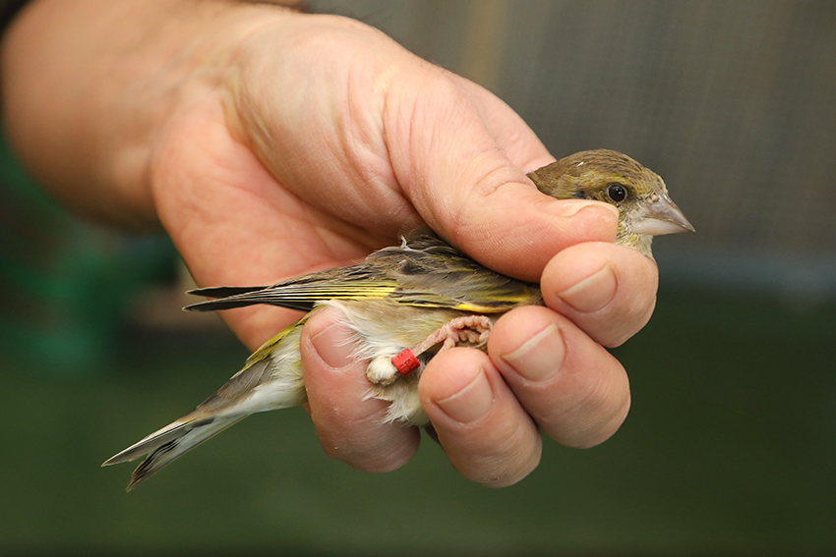For mounted Birds Directive birds originating from breeding, a seamless closed leg ring serves as evidence that the bird has been legally obtained. These birds may be traded.

Figure 10: A greenfinch with a leg ring

**Attention! Birds can also be both Birds Directive species and CITES species! In this case, the highest level of protection applies, which is CITES. You will then need to comply with the obligations of CITES.**

## Game and damage-causing species

Despite all native birds being protected, there are also some species designated as game or damage-causing species. These species may, for example, cause damage to crops or be selected for hunting. These species can also be freely traded, provided that one can demonstrate that the animal is of hunting origin. This can be done by showing, for example, a hunting permit or a transfer statement from the hunter.

|  |  |  |  |
| --- | --- | --- | --- |
| Soort |  | Soort |  |
| Wood pigeon[6] | Faunabeheereenheden Nederland > DIERSOORTEN > Diersoorten Nederland >  houtduif | Mallard[7] | Wilde eend - Onze Natuur |
| Jackdaw[8] | Kauw - Coloeus monedula - Waarnemingen.be | Canadian goose[9] | Canadese gans | Ecopedia |
| Carrion crow[10] | Zwarte kraai | Vogelbescherming | Pheasant[11] | Ecoduct Meedenpad Groningen informatietafel fazant - Bureau Biota |

# Habitat directive species

Similar to the Birds Directive legislation, there are also several species covered under the Habitat Directive legislation. The Habitat Directive, like the Birds Directive, aims to protect species. Species listed under the Habitat Directive include the wolf, beaver, and otter. These animals (or parts thereof) may not be possessed or traded without proper authorization. (Parts of) species listed in Annex IV of the Habitat Directive may not be possessed or traded unless it can be demonstrated that these animals or plants are of captive-bred origin.

To see which animals are included in Annex IV of the Habitat Directive, please visit the following website: <https://minlnv.nederlandsesoorten.nl/content/habitatrichtlijn-soort-van-habitatrichtlijn-bijlage-iv> or scan the QR code provided on the left.

# Bern and Bonn conventions

Finally, there are also two treaties for some other species. The Bern Convention protects endangered species, and the Bonn Convention aims to protect migratory species. If you own or intend to trade (products of) these animals, you must be able to demonstrate their legal origin. Scan the QR codes below to see which species are covered or visit:: <https://minez.nederlandsesoorten.nl/content/bern-conventie> and <https://minez.nederlandsesoorten.nl/content/bonn-conventie>.



Bonn convention (Dutch)

Bern convention (Dutch)

# Other game- and damage causing species

In addition to the mentioned birds, other animals have also been designated as game and damage-causing species..

|  |  |  |  |
| --- | --- | --- | --- |
| Soort |  | Soort |  |
| European rabbit[12] | Europees konijn | Fallow deer[13] | Damhert - Dama dama - Waarneming.nl |
| Hare[14] | Haas | DierenWiki | Hazen en Konijnen | Haas | Red deer[15] | Edelhert - Veluwezoom In Beeld |
| Fox[16] | Vos - Veluwezoom In Beeld | Wild boar[17] | Wild Zwijn - Sus scrofa - Waarnemingen.be |
| Roe deer[18] | Ree - Hubertus Vereniging Vlaanderen |

These species may be hunted in certain areas and under certain conditions. If it can be reasonably demonstrated that mounted animals or parts of these animals originate from hunting (or breeding), trade is permitted in principle (similar to the designated bird species for hunting). This can be done, for example, with a transfer document from the hunter or a hunting permit.

# Fur

*It's important to remember that all large felids (and thus their fur) are protected under CITES. Products with fur from felids such as the caracal, lynx, tiger, lion, jaguar, and leopard cannot be traded indiscriminately. Check if the species is listed on CITES by entering the scientific name on* [*www.speciesplus.net*](http://www.speciesplus.net)*.*

What is also common are items made of or with fur. Typically, this involves unprotected fur, such as that of mink, raccoon dog, or raccoon. However, the fur can also originate from protected animals. Here, we will mention some common examples. Please note! This overview is for informational purposes and is therefore not exhaustive!

## Canadian lynx

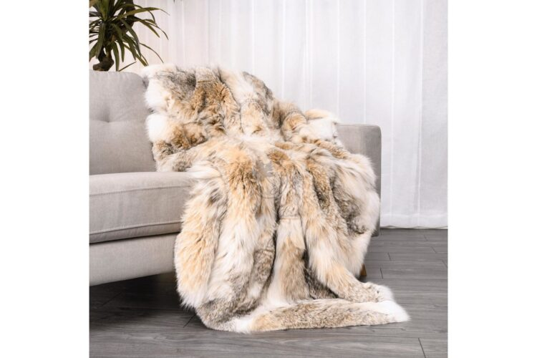The fur of the Canadian lynx is a sought-after fashion item. As the name suggests, this animal is found in North America. The Canadian lynx is protected under CITES, and an import permit is required for its import into the European Union. To trade in fur products from the Canadian lynx, the legal origin must be proven.[19]

Fur of a Canadian lynx21

## Eurasian Lynx - an overview | ScienceDirect TopicsEurasian lynx

The Eurasian lynx is protected under both CITES and the Habitat Directive. Therefore, you may not possess or trade Eurasian lynxes or products thereof unless you can demonstrate that the animal or product is of captive-bred origin. [20]

A Eurasian lynx22

## Vintage Real Ocelot Fur Jacket,1950'S - MANHATTAN'S BABEOcelot

The ocelot, with its spotted pattern, is a beautiful sight. Its fur is often used in fur products, such as the coat pictured here. The ocelot is protected under CITES, so when dealing with (parts of) this species, a certificate must be included.. See <https://www.rvo.nl/onderwerpen/cites/dit-cites> (Dutch) for more information on certificates.

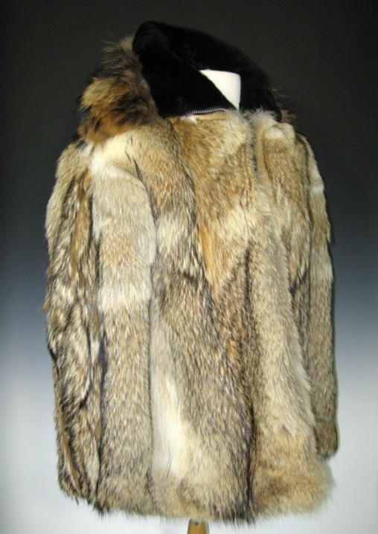

An ocelot fur coat23

## Wolf

For many people, the wolf is not an unfamiliar species. This species is heavily protected under CITES. Trade in (parts and products of) the wolf is highly regulated. Like with the ocelot, a certificate is required.[21]

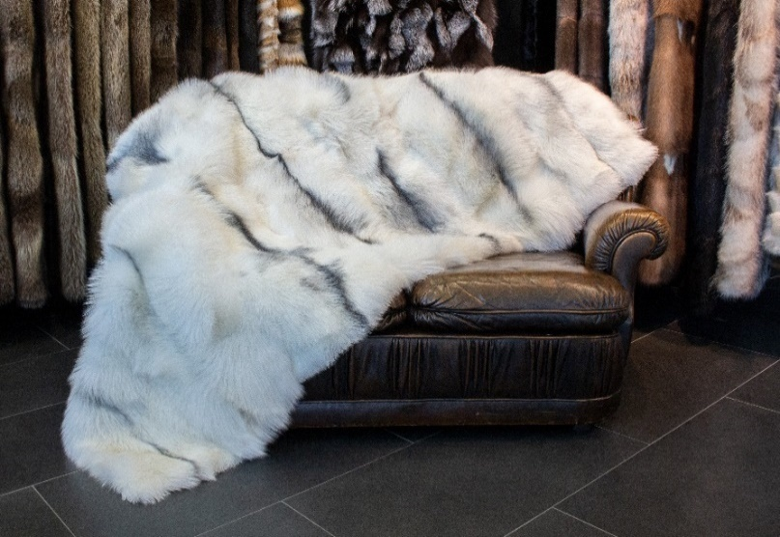

A wolf fur coatt24

## Arctic fox

The Arctic fox is protected under the Habitat Directive. Since this directive only protects European populations, (products of) Arctic foxes from, for example, Russia and America are not protected. However, you must be able to demonstrate that the fur is not derived from the European Arctic fox.[22]

A rug made of Arctic fox fur25

## Zebra

*If you're unsure whether you're dealing with real or faux fur and suspect it might be protected fur, consult an expert or send a photo to the NVWA or RVO. We're here to assist you.*

When people talk about zebras, they often refer to them as if they are one species. In reality, there are different species of zebras. Some of these are protected under CITES. If you possess zebra fur and wish to trade it, it is advisable to determine the exact species and level of protection.. [23]

A rug made of zebra skin26

## Taxidermy Alaskan Brown Bear Rugs For Sale Grizzly Bear RugBeer

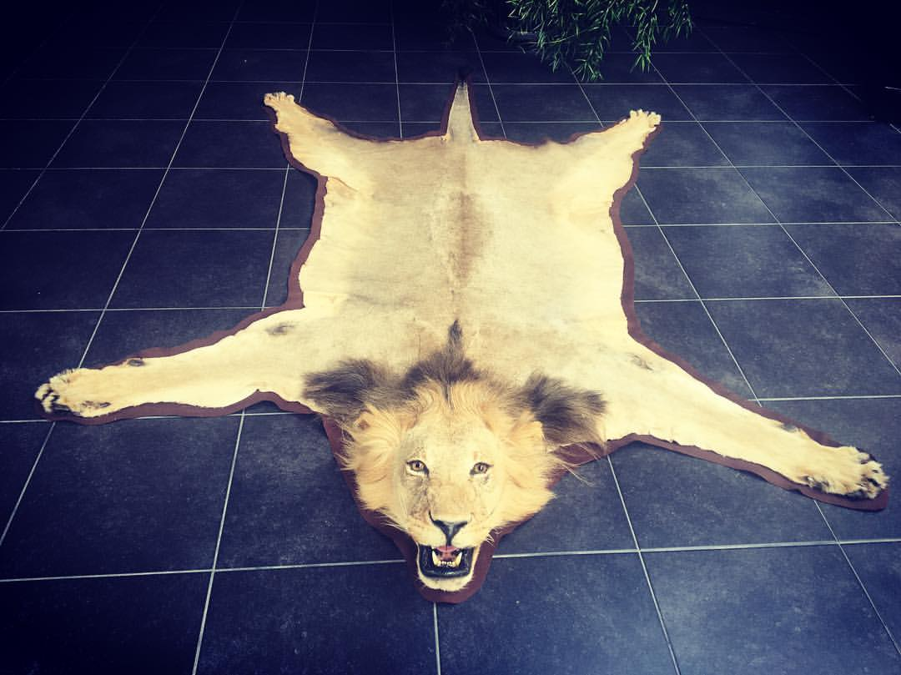All species from the bear family are protected under CITES. This means that if you want to trade a bear skin like the one pictured here, you must be able to demonstrate its legal origin through an import permit or transfer certificate.[24]

Rug of an American brown bear27

## Lion

An easily recognizable animal, the lion is also protected under CITES. For the trade in (African) lion products, the legal origin must also be demonstrated. This can be done, for example, by presenting the import permit.[25]

A rug of lion skin28

# Reptile leather

What is also frequently encountered in markets and trade are products made from reptile leather. However, many reptiles are protected under CITES. It is therefore important to know if you are selling leather products and whether they originate from protected animals. Below, we will discuss some common reptile species that are processed into leather products such as bags, wallets, and watch straps.

## Reticulated Python – BC – Yellow- Glazed | Roje Exotic LeatherReticulated python

Most of the leather we see in circulation is derived from the reticulated python. This snake is protected under CITES, so demonstrating legality (for example, with a transfer certificate) is necessary if you wish to sell reticulated python leather products. On the right, you can see the typical pattern of a reticulated python. Often, the skin is dyed, and the pattern is no longer (clearly) recognizable.[26]

## 

Reticulatef python leather29

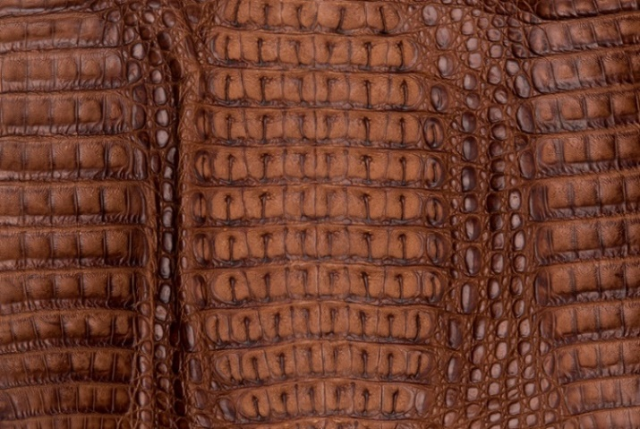

## Crocodile leather

Leather products from crocodiles, alligators, and caimans are also protected under CITES. Often, these skins are dyed, as shown on the caiman skin displayed here on the left.[27]

Dyed caiman leather30

## Monitor lizards

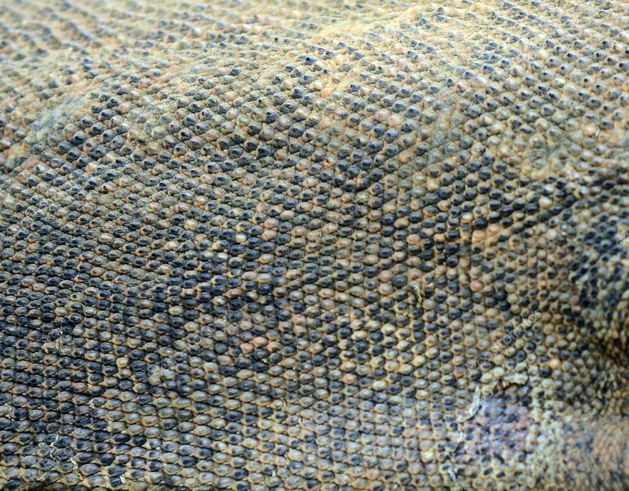All species of monitor lizards are protected under CITES. Leather from monitor lizards is easily recognizable by the dark "rice grain" present in each scale (see the image below for an example). Rules apply for trading in (leather products from) monitor lizards..[28]

Monitor lizard leather31

# Turtle and tortoise

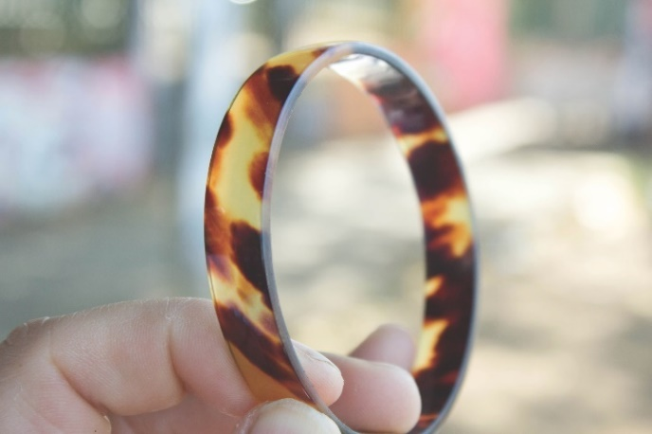Commonly encountered are products made from turtle and tortoise shells. These products are typically made from the shell. Many turtles (and even all sea turtles) are heavily protected under CITES. Trade in these species is therefore very restricted, and there are many requirements. Usually, products like the one shown here on the right are turtle shell, or think, for example, of small jewelry boxes..[29]

A bracelet made of tortoise shell32

# Closing remarks

This document is for informational purposes and mainly contains commonly encountered products and animals. However, it is not comprehensive. It can sometimes be difficult to see the forest for the trees. If you have doubts about an object or mounted animal, you can always ask a question to the NVWA or RVO. They are happy to assist you!

## NVWA

With this QR code, you will be directed to the contact page of the Netherlands Food and Consumer Product Safety Authority (NVWA). Here, you can ask your questions.

[https://english.nvwa.nl/about-us/contact](https://www.nvwa.nl/contact)

## RVO

With this QR code, you will be directed to the contact page of the Netherlands Enterprise Agency (RVO). Here, you can also ask your questions.

<https://english.rvo.nl/onderwerpen/contact>

1. <https://www.butterflyplanet.com/ornithoptera-and-trogonoptera-ornithoptera-9197305.html>
2. <https://jordaens.eu/lot/een-grote-slagtand-van-een-afrikaanse-olifant-met-cites-certificaat-be01402016-25kg/>
3. <http://www.lab.fws.gov/Ivory/elephant.html>
4. <https://blademag.com/blog/steve-shackleford-blog/distinguishing-elephant-ancient-ivory>
5. <https://wetten.overheid.nl/jci1.3:c:BWBR0041330&hoofdstuk=11&afdeling=11.2&paragraaf=11.2.9&artikel=11.102&z=2024-01-01&g=2024-01-01>
6. <https://www.faunabeheereenheid.nl/noordbrabant/DIERSOORTEN/dieren-Noord-Brabant/houtduif>
7. <https://www.onzenatuur.be/soortenbank/wilde-eend>
8. <https://waarnemingen.be/species/126/>
9. <https://www.ecopedia.be/dieren/canadese-gans>
10. <https://www.vogelbescherming.nl/ontdek-vogels/kennis-over-vogels/vogelgids/vogel/zwarte-kraai>
11. <https://natuurlr.nl/events/start-natuurbingo-meld-roepende-fazanten/>
12. <https://www.onzenatuur.be/soortenbank/europees-konijn>
13. <https://waarneming.nl/species/382/>
14. <https://dierenwiki.nl/wiki/haas>
15. <https://veluwezoominbeeld.nl/natuurinfo/zoogdieren/edelhert/>
16. <https://veluwezoominbeeld.nl/natuurinfo/zoogdieren/vos/>
17. <https://waarnemingen.be/species/432/>
18. <https://hvv.be/soorten/ree/>
19. <https://www.henigfurs.com/collections/fur-blankets/products/full-skin-lynx-fur-blanket>
20. <https://www.sciencedirect.com/topics/agricultural-and-biological-sciences/eurasian-lynx>
21. <https://garystockbridge617.getarchive.net/amp/media/president-fords-wolf-skin-coat-553121>
22. <https://www.master-furrier.com/fur-blankets-fur-throws/fox/blue-frost-fox/>
23. <https://cowhidesinternational.com/shop/other-animal-hides/real-zebras/authentic-standard-grade-zebra/>
24. <https://www.wildlifetaxidermy.com/grizzly-bear-rugs-(large-ex-large).html>
25. <https://www.masaigallery.com/en/product/lion-rug/>
26. <https://www.rojeleather.com/products/reticulated-python-bc-yellow-glazed/>
27. <https://shop.panamleathers.com/caiman-hornback/>
28. <https://www.istockphoto.com/nl/foto/komodo-dragon-huid-close-up-gm650246240-118146609>
29. <https://www.seaturtlestatus.org/articles/swot-report-16-trade-in-hawksbill-shell-still-active-globally>